**Supplementary Requirement Release 2**

1. **FV – Field Validation - Username**

**Scope:**

07.01. Modify General Users Information

07.02. Reset the password

**Requirements:**

* On the My Profile page (.../myDashboard), if the user wants to modify his/her username, enter information with text type.
* The system shows the current username on the screen.

To modify it, the user has to clear the field to input new data and then click on ‘Update’ to save the new data.

* The username field has to be an email id, if not it will throw an error message below the text field in red color - ‘Please include an ‘@’ symbol in the email address.

**Conditions to Apply:** After the respective join points.

1. **FV – Field Validation - Password**

**Scope:**

07.01. Modify General Users Information

07.02. Reset the password

**Requirements:**

* On the My Profile page (.../myDashboard), if the user wants to modify his/her password, enter information with text or number type.
* The system shows the current password on the screen.

To modify it, the user has to clear the field to input new data and then click on ‘Update’ to save the new data.

* The password field has conditions:

Rule 1 - if field size exceeds, then an error message appears below the text field in red color - ‘Length must be greater than 8 characters. Rule 2 - if the field has only letters then an error message appears below the text field in red color - ‘Must contain numbers’.

**Conditions to Apply:** After the respective join points.

1. **Data Flow In**

**Scope:**

07.01. Modify General Users Information

**Requirements:**

* The user creates an account or signs in by entering the data with text type for username and number type and text type for password.
* While the user is logged in and is On the My Profile page (.../myDashboard), the initially created username are displayed.

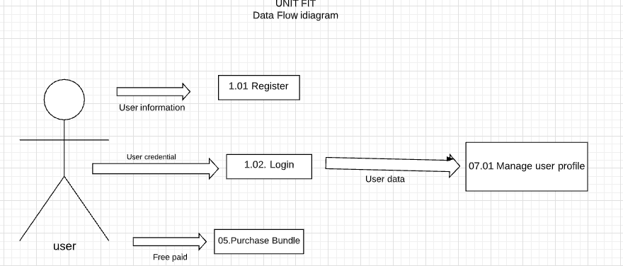

**Conditions to Apply:** After the respective join points.

1. **Exception Handling**

**Scope:**

07.01. Modify General Users Information

07.02. Reset the password

**Requirements:**

* When the user is trying to update the username and password, but the information does not get updated as the database connection is interrupted, an error message is thrown in red color below the page - “Information cannot be saved right now”.

**Conditions to Apply:** After the respective join points.